**Question – 1 :-**  List the basic registers used for timers in AVR ATMEGA32 along with their uses.

**Answer :-**

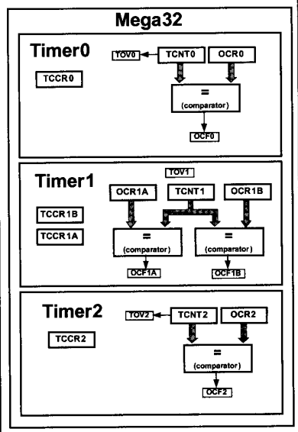

1. **TCNT(**Timer/Counter Control Register**) :-**

* Timer/Counter Register that initializes to zero upon reset. It increments with each clock pulse.

**2)TOV(**Timer Overflow Flag**) :-**

* It will be set when timer overflows.

1. **TCCR(** Timer/Counter Control Registers **) :-**

* This Registers is used for setting the modes of Operation.

1. **OCR(** Output Compare Registers**) :-**

* The Content of the OCR is Compared with the content of the TCNT

1. **ICR (** Input Capture Register **) :-**
2. **ASSR (**Asynchronous Status Register**) :-**

* It Used for External clock sources.

**Question – 2:-**   Determine the timer's clock frequency and its period for various AVR based systems, with below mentioned crystal frequencies. Assume that no prescalar is used.

1. 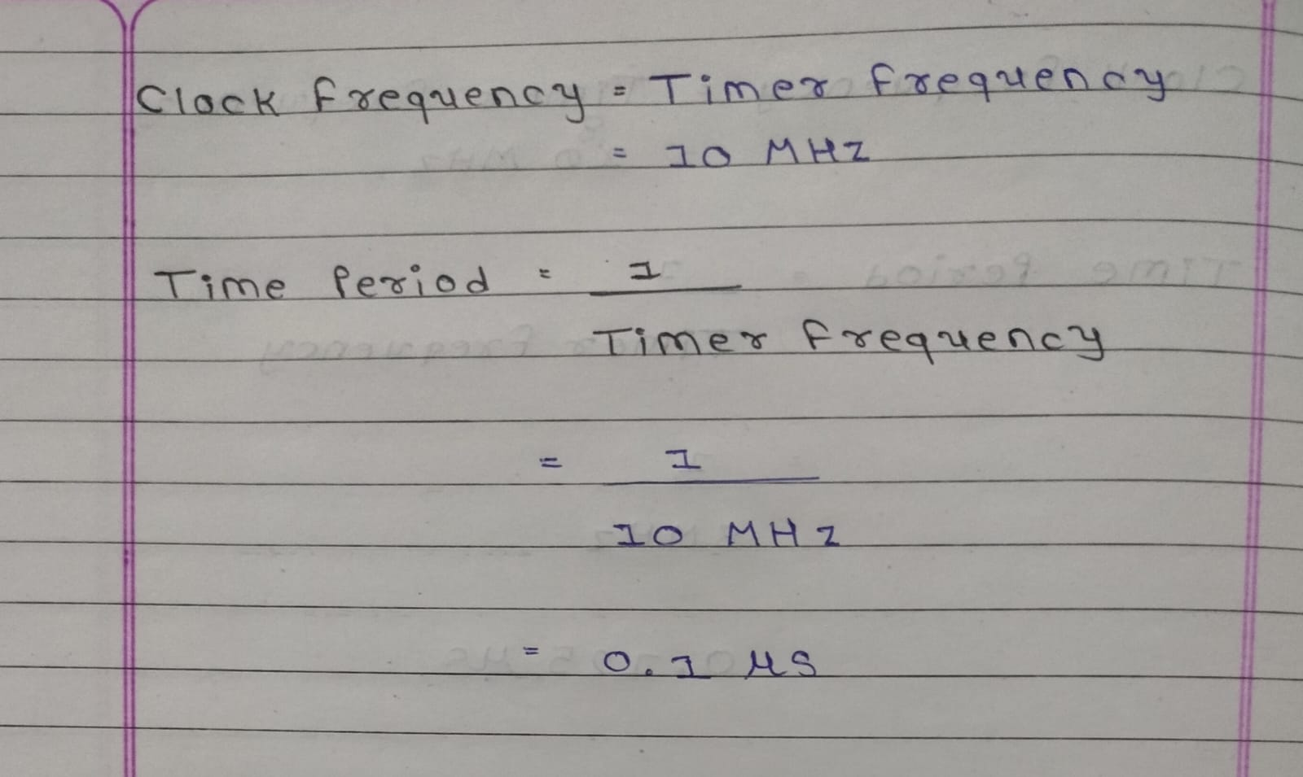10 MHz
2. 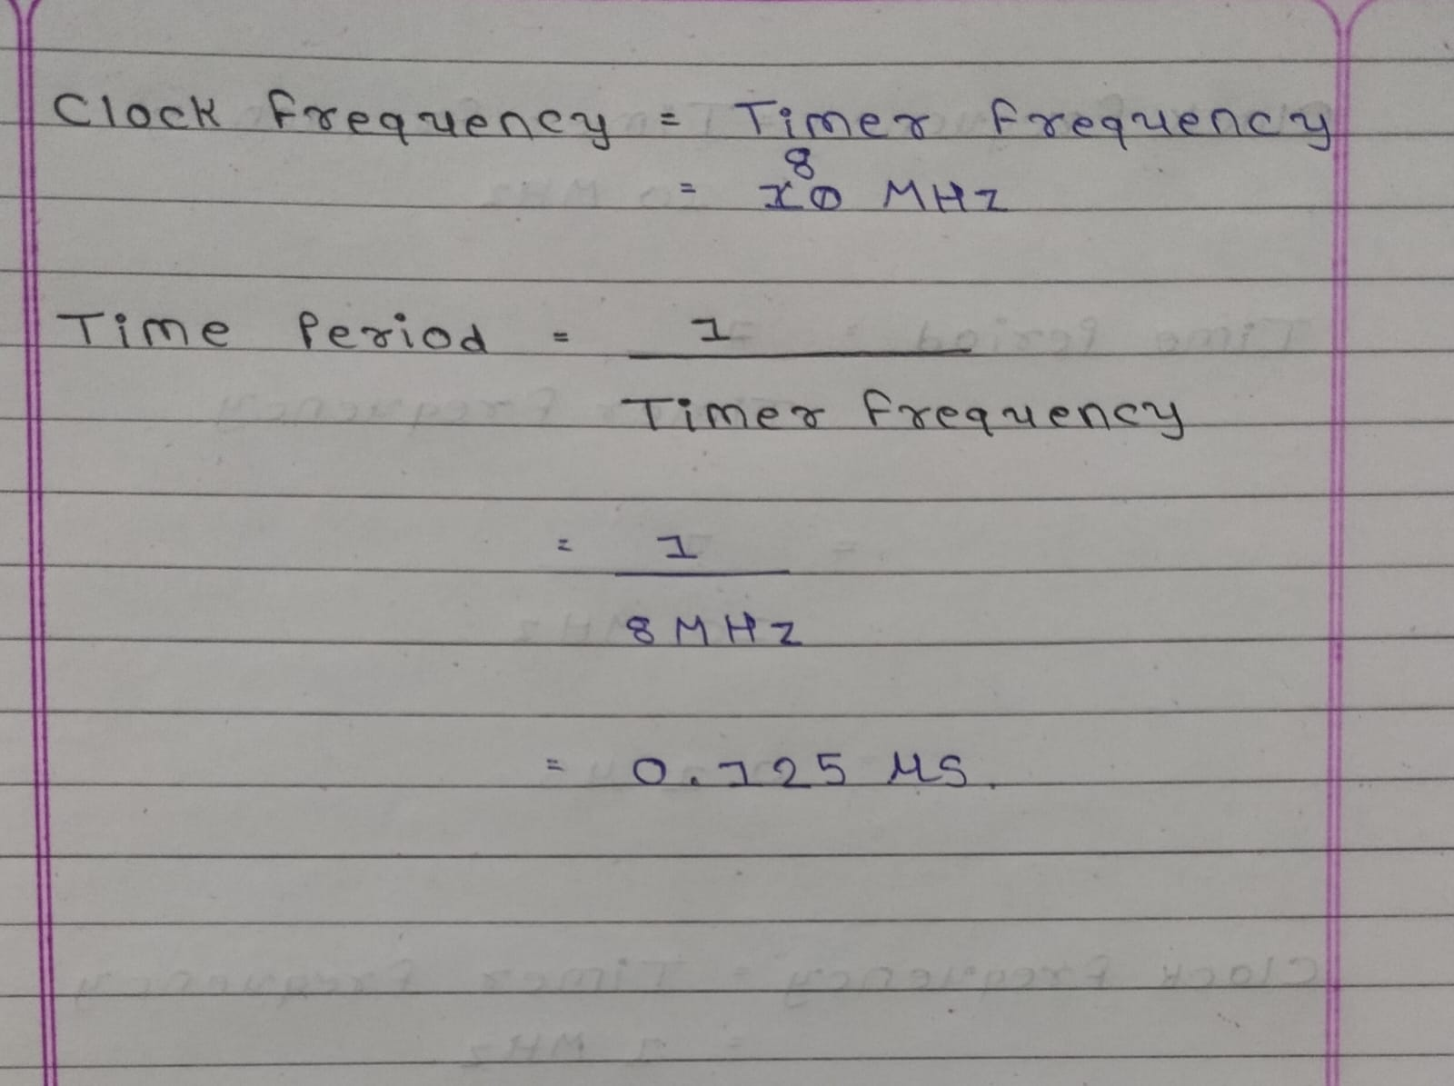8 MHz
3. 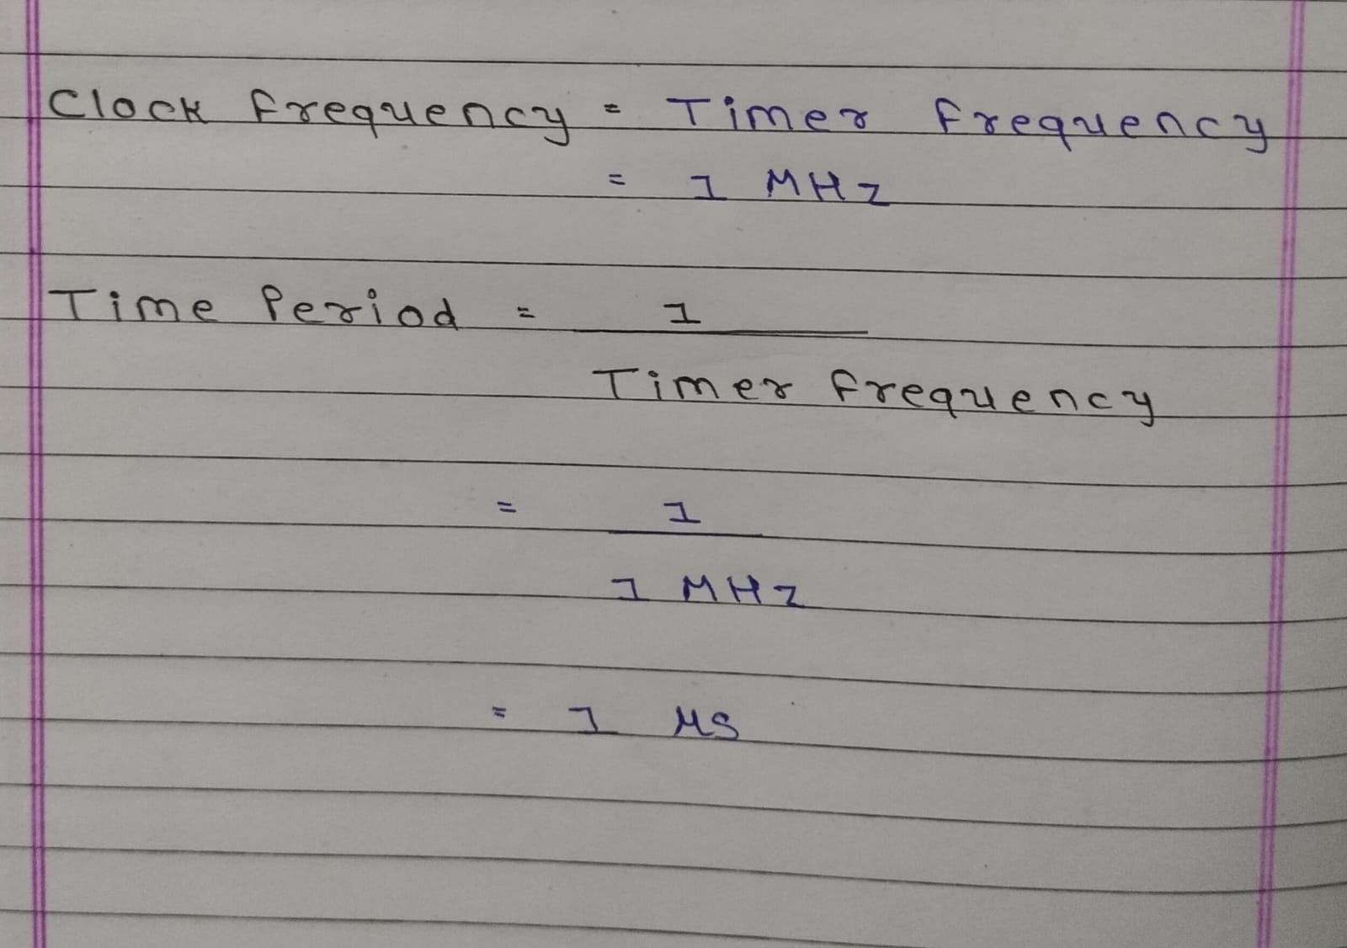1 MHz

**Question – 3:-**   Write a program to generate a square wave with a period of 12.5us on pin PORTB.3. Assume that XTAL = 8MHz.

**Answer :-**

void Generate_Delay() {

TCNT0 = 0xCE ;

TCCR0 = 0x01 ;

while (TCNT0 != 0) ;

}

int main(void)

{

PORTB = 0x00 ;

while (1) {

PORTB = 0x08 ;

Generate_Delay();

PORTB ^= 0x08 ;

}

}

**Question – 4:-**   Write a C program to toggle all the bits of PORTB continuously with a delay of 10ms. Use Timer 0, normal mode, with suitable prescalar to generate the delay. Assume the frequency to be 8MHz

**Answer :-**

#include <avr/io.h>

#include <avr/delay.h>

#include <util/delay.h>

#define *F_CPU* 16000000UL

void Generate_Delay() {

TCNT0 = 0xF6 ;

TCCR0 = 0x02 ;

while(TCNT0 != 0) ;

}

int main(void)

{

DDRB = 0xFF ;

PORTB = 0x00 ;

while (1) {

PORTB = 0xFF ;

Generate_Delay();

PORTB ^= 0xFF ;

}

}

**Question – 5:-**   Write a C program to toggle only PORTB.4 bit continuously every 70us. Use Timer 0, Normal Mode, and 1:8 prescalar to create the delay. Assume XTAL= 8MHz.

**Answer :-**

#include <avr/io.h>

#include <avr/delay.h>

#include <util/delay.h>

#define *F_CPU* 16000000UL

void Generate_Delay() {

TCNT0 = 0xBB ;

TCCR0 = 0x02 ;

while(TCNT0 != 0) ;

}

int main(void)

{

DDRB = 0xFF ;

PORTB = 0x00 ;

while (1) {

PORTB = 0x10 ;

Generate_Delay();

PORTB ^= 0x10 ;

}

}